Assignment 3

Digital education platform based on professor as a service model

Assignment by team:

Sanjana Chatti (002105435)
Prudhvi Hari Sai Charan Nakkina (002928761)
Sai Charan Reddy Maila (002923445)

PROJECT OBJECTIVE

The goal of the project is to develop a decentralized digital learning platform for professors and students across the globe, which is different from the traditional university setup.

Abstract

The objective of this project is to implement “professor as a service” model where the professor has the full autonomy and manages his own courses, sets the course fee based on the demand. Students enroll for courses under different professors to attain their degree.

Approach

The three major components which are important in this system are as follows:

Professor:

- Professors signs up to the platform by paying the subscription fee
- Professor services are visible and accessible using any smart devices
- The course prices are set by the professor
- The tuition for courses goes directly to the professor

Student:

- Students can access the platform form anywhere in the world using any smart device like tablets, phones, browsers
- Students can enroll for multiple courses under different professors
- Students can choose a third-party certification authority to get their degree approved

Certification authority:

- Each certification authority has their own set of employers
- The certification authority approves the degree of the student once the course requirements are fulfilled

Flow of the MODEL

- Professor will login using his/her credentials
- Professor pays the subscription fee to use the platform
- Professor adds his courses to the portal and also sets the price and schedules the courses
- Student logs in using his/her credentials
- Student goes through the available professors in the portal and selects the professor
- Student selects the course under professor and enrolls for it
- Student pays the tuition fee to the platform which will be paid to professor
- Student completes the enrolled courses
- Student selects one of the third-party Certification authorities based on their employer tie ups and requests them for degree approval
- Certification authority verifies the student courses and approves the degree

ENTITIES

DigitalEducationPortal:

Attributes:

- professors
- subscriptionFee
- students
- thirdPartyAuthorities

Professor:

Attributes:

- courses
- userName
- professorName

Methods:

+ setCoursePrice (): this method takes course as an argument and sets the price for the course
+ scheduleCourse (): this method takes course as an argument and schedules the course
+ paySubscriptionFee (): this method allows the professor to pay the subscription fee for platform

Student

Attributes:

- enrolledCourses
- coursesCleared
- students
- studentName
- userName
- password

Methods:

+ requestCertificationApproval (): this method is used to make the request to certification authority for the degree approval
+ payTution (): this method is used to pay the tuition for the courses
+ selectProfessor (): this method allows the student to choose the professor according to the course.
+ enrollCourse (): this method allows the student to decide and enroll in the course
+ rateProfessor (): this method allows the student to give feedback depending upon how the course went
+ rateCourse (): this method allows the student to give their opinions in the course structure and if any changes have to be done

Certification authority

Attributes:

- employers
- degree

Methods:

+ validateDegree (): this method allows the third party to verify if the student met all the requirements for the course and then validates the degree

Admin

Attributes:

- username
- password

Methods:

-viewDashBoard (): allows the admin to view the dash board

Login

Attributes:

- username
- password

Methods:

+ validateCredentials (): checks if the given credentials are valid

Course:

Attributes:

- price
- reputationIndex
- scheduledTime
- courseid

Degree:

Attributes:

- requiredCourses

Methods

+ approvedDegree (): this method approved the degree if all the requirements are met

Enrolled courses:

Attributes:

- enrolledCourses

Diagrams

Class Diagram

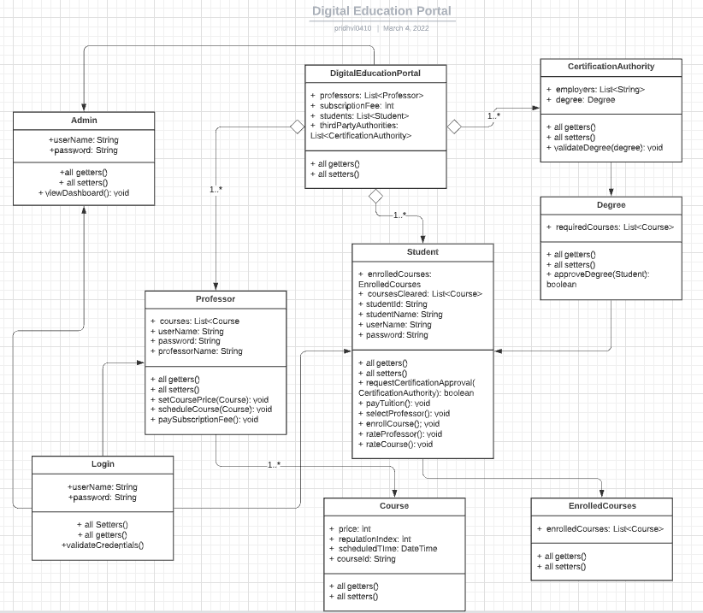
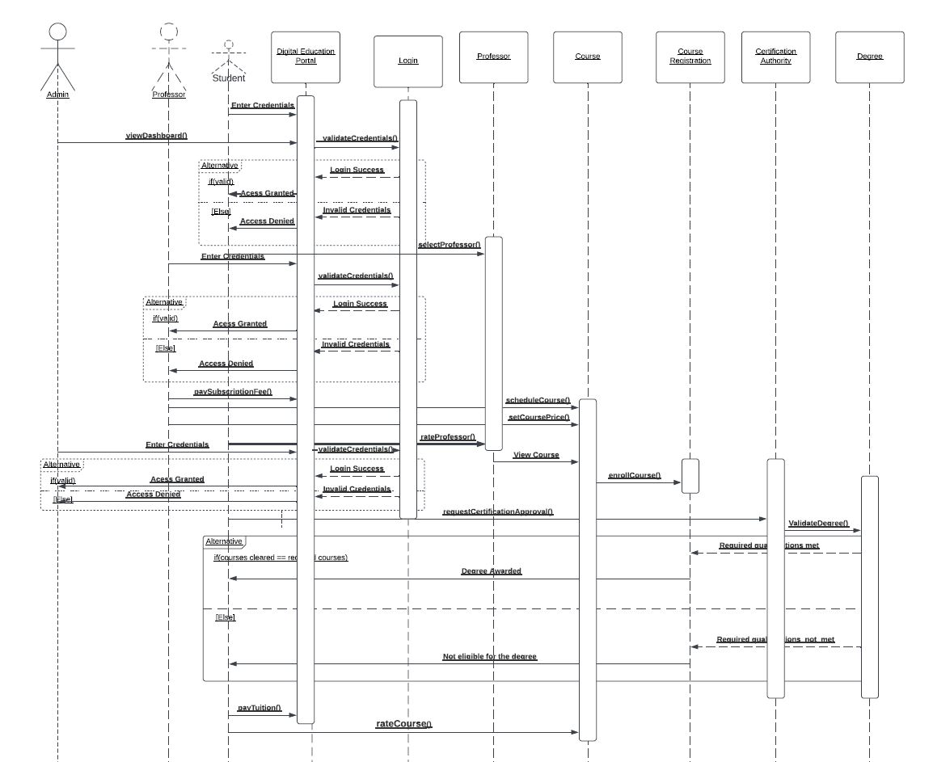

Sequence Diagram

USER INTERFACE

Login

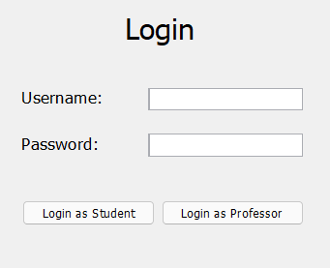

Professor dashboard

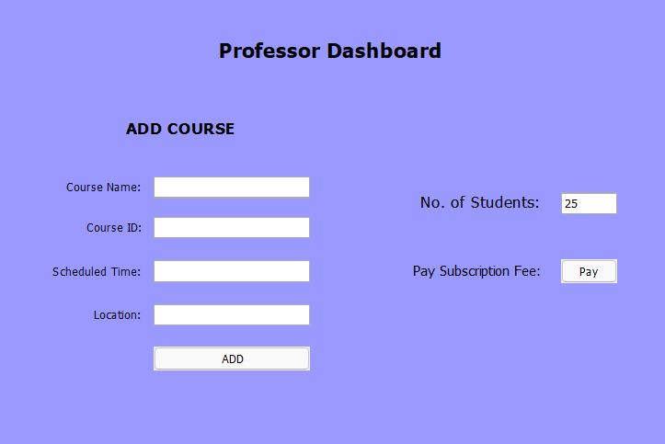

Student dashboard

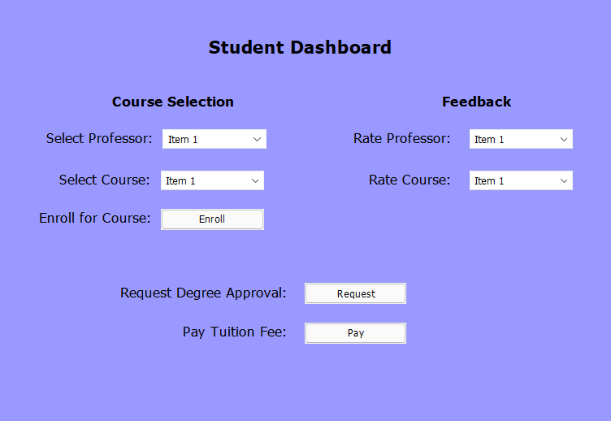

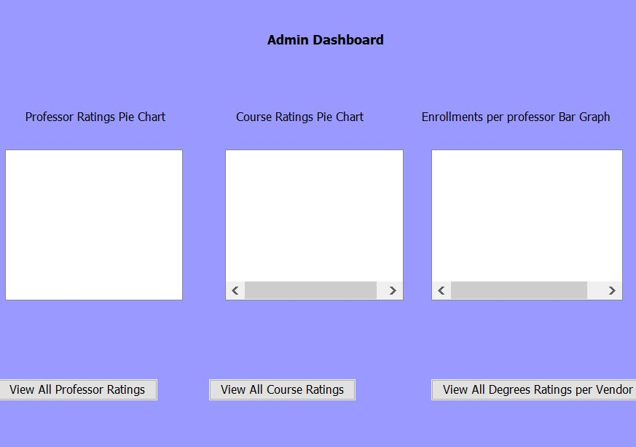
Admin dashboard

